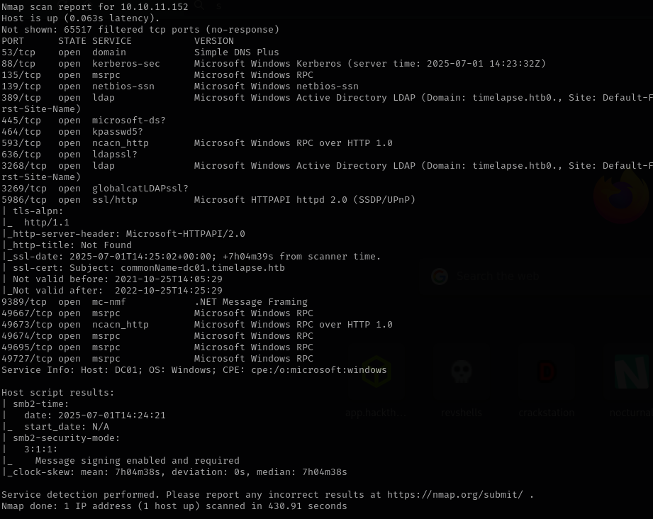
The nmap scan reveals an Active Directory machine running.
We start with basic enumeration in order to find an attack surface.
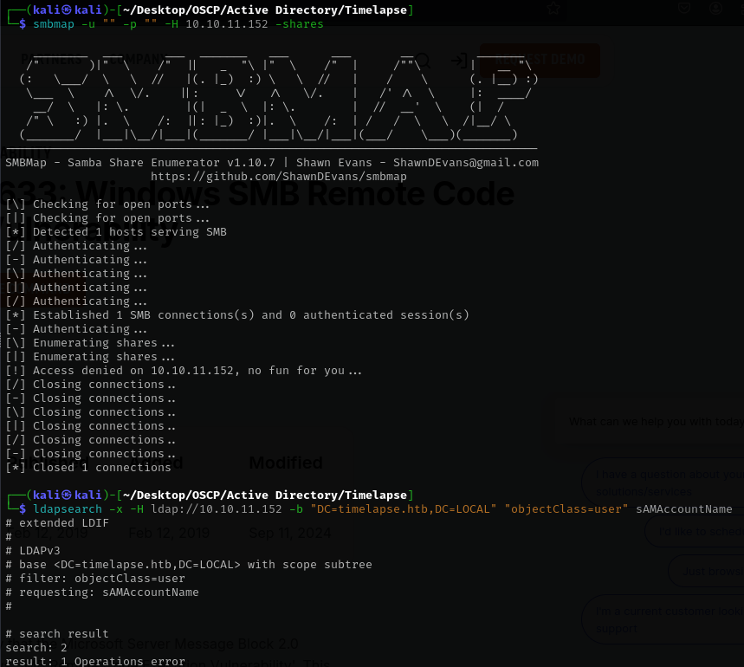
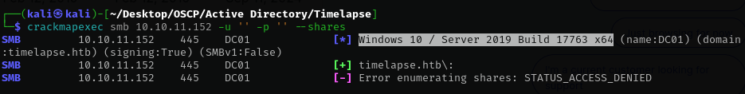
It looks like anonymous authentication is disabled so we need to use impacket GetNPUsers.py in order to find some valid users.
While GetNPUsers enumerated roastable users, I forgot I could check with smbclient if we have access to the shares (even if crackmapexec or smbmap couldn’t provide anything) and success
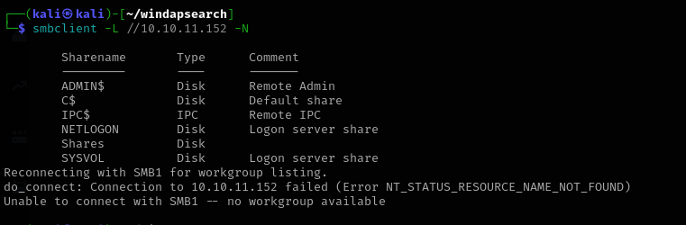
We have some shares available. Now let’s try to connect to “Shares” and success
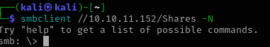
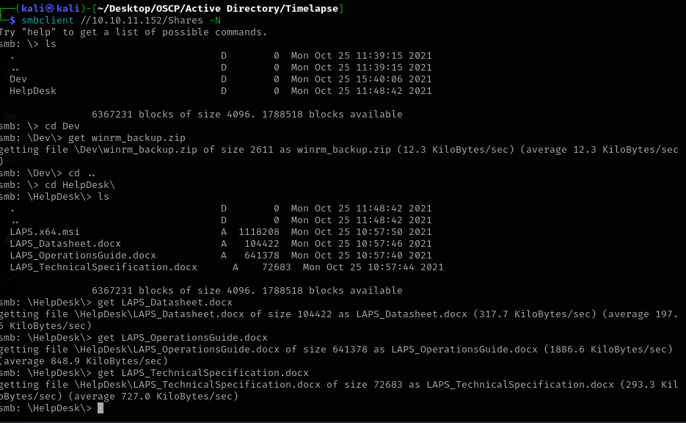Once inside, I downloaded all the files I could find in order to analyse them on my attacking machine.

I’ve used zip2john in order to create the zip_hash 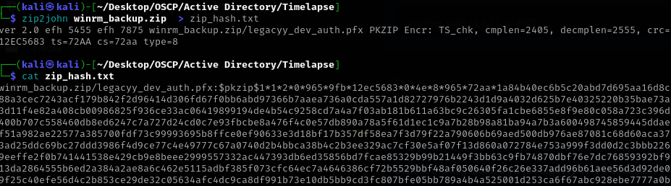
Then I’ve used john to crack the hash, giving us a password to extract the zip.After that I performed the same technique but with pfx2john in order to get the .pfx password
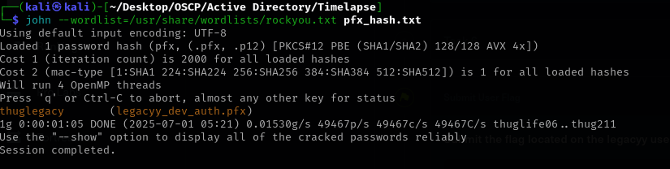
After I extracted the authentication certificate, I’ve managed to get inside
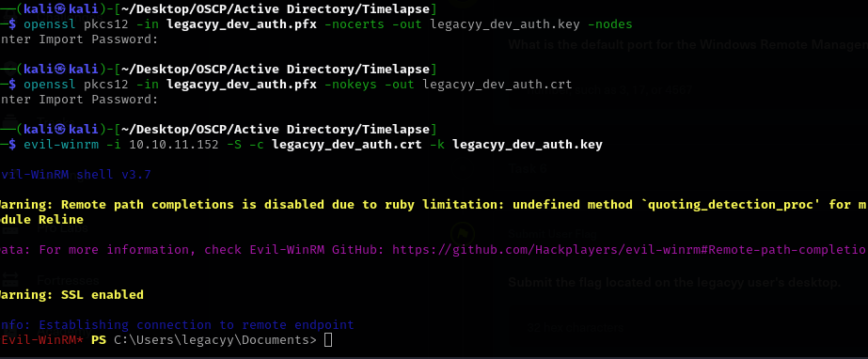
Now for privilege escalation I’ve used the Hints. They say that we have a Powershell history file which may save passwords and such.
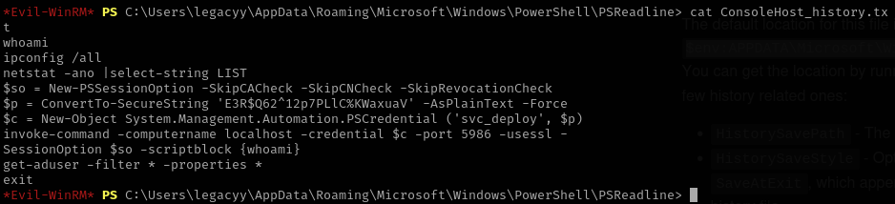
Using cat to open the file gives us what may seem to be a password and user for svc_deploy.
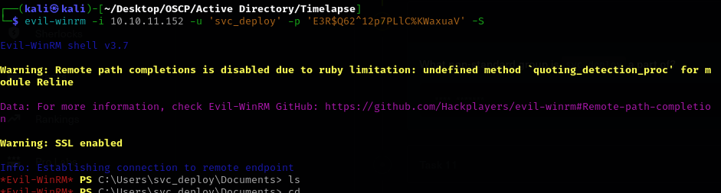
We are using -S flag because without the flag evil-winrm would try to connect to port 5985 not 5986 and the connection would time-out.
Once, inside we run whoami /groups and /priv
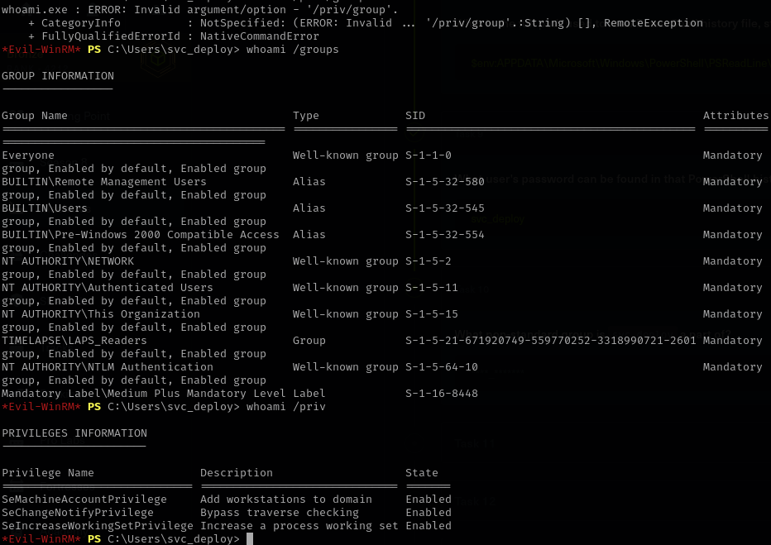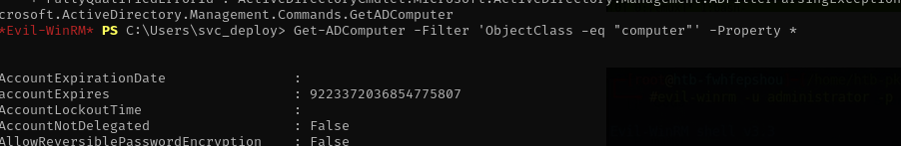
Using the GET-ADComputer got us the password
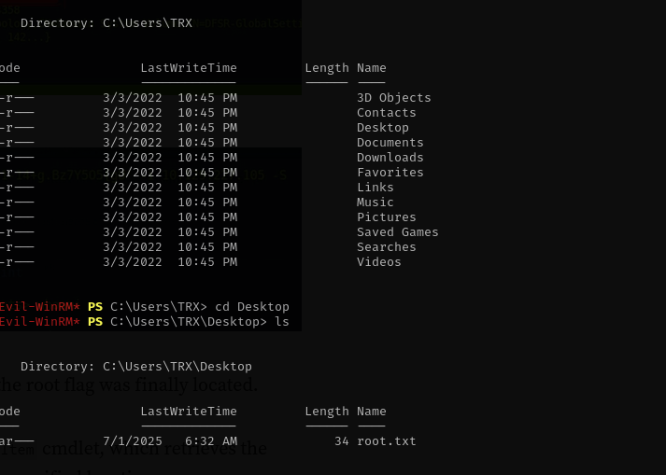

Here's a summary of the steps taken to compromise the machine, starting from the nmap command:
- Nmap Scan: An initial nmap scan was performed on the target machine (10.10.11.152) to discover open ports and services, revealing that WinRM (ports 5985/5986) was open.
- Initial Access as svc_deploy: Using credentials for the svc_deploy user (which were found through prior enumeration, likely from command-line history), access was gained to the system via evil-winrm.
- Group Membership Enumeration: Once authenticated as svc_deploy, it was determined that this account was a member of the LAPS_Readers group.
- LAPS Computer Enumeration: The Get-ADComputer cmdlet was used with a filter to list all computer objects in the Active Directory, including their properties, to identify machines managed by LAPS.
PowerShell
Get-ADComputer -Filter 'ObjectClass -eq "computer"' -Property *
- LAPS Password Retrieval: From the output of the Get-ADComputer command, the ms-Mcs-AdmPwd attribute was found for DC01, revealing the LAPS password: 6]s7cy;[#4+uL2aV/{2(8u@-. This password corresponds to the local administrator account (which, for a Domain Controller, is typically the domain's built-in Administrator account).
- Domain Administrator Access: With the retrieved LAPS password, a successful evil-winrm connection was established as the administrator user, gaining Domain Administrator privileges on the machine.
Bash
evil-winrm -i 10.10.11.152 -u administrator -p '6]s7cy;[#4+uL2aV/{2(8u@-' -S

